**/describe**

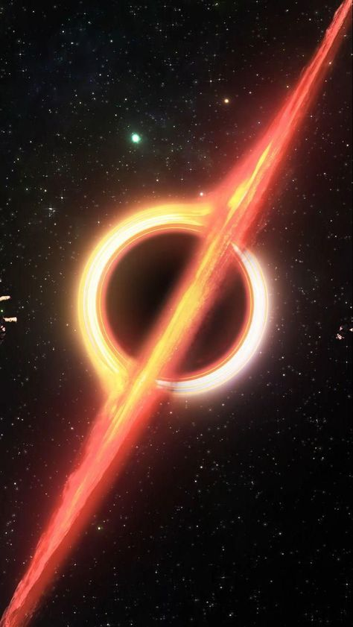

1️⃣ a black hole and a red light, in the style of light gold and orange, anime-influenced, multiple flash, earthcore, chalk, group zero, rtx --ar 59:105

2️⃣ a picture of a black hole rising from space, in the style of toonami, light red and gold, geoff johns, dan matutina, multiple flash, rainbowcore, chalk --ar 59:105

3️⃣ an image in space, with a large black hole, in the style of light red and gold, toonami, multiple flash, chalk, dc comics, nostalgiacore, rainbowcore --ar 59:105

4️⃣ image of a small spaceship with stars and black holes, in the style of toonami, geoff johns, gabriel dawe, multiple flash, close-up intensity, red and gold, q hayashida --ar 59:105

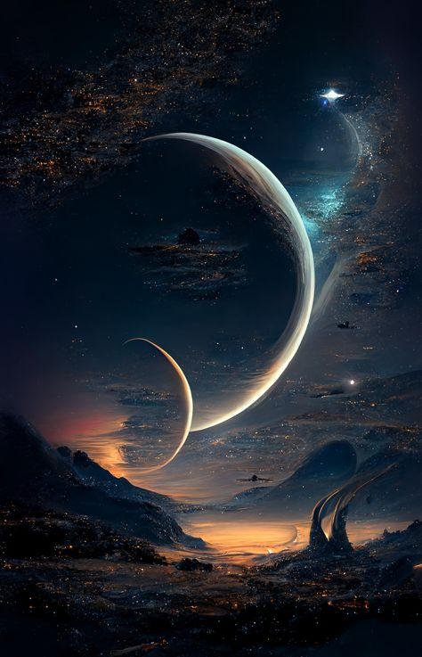

1️⃣ planet planet art wallpaper planet of the week galaxy hd wallpapers hd planet of the week moon space planet hd wallpaper space planet wallpaper, in the style of impressive panoramas, fantasy-inspired art, colorful moebius, gothic futurism, the stars art group (xing xing) --ar 59:92

2️⃣ space art digital galaxy hd wallpaper, in the style of imaginative fantasy landscapes, dark gold and dark cyan, colorful moebius, i can't believe how beautiful this is, serene and tranquil scenes, tanya shatseva, long distance and deep distance --ar 59:92

3️⃣ spaceship planet wallpaper 2d 1080p, in the style of otherworldly paintings, impressive panoramas, emily balivet, night photography, smooth and curved lines, evgeni gordiets, dreamlike figures --ar 59:92

4️⃣ one of the outer planets in the night, in the style of gothic futurism, serenity and calm, photo-realistic landscapes --ar 59:92

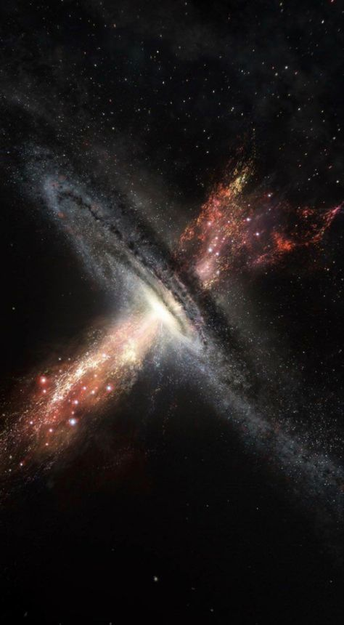

1️⃣ the milky way is a complex star system, in the style of spiritual dimensions, focus on joints/connections, hyperspace noir --ar 59:107

2️⃣ galaxy explosion on the horizon, in the style of precisionist lines, spirals and curves, exacting precision, multidisciplinary, alexandre calame, sparklecore, furaffinity --ar 59:107

3️⃣ an artist's rendering of the red galaxy, in the style of light black and bronze, aerial view, whirly, science academia, focus on joints/connections, abrasive authenticity, #vfxfriday --ar 59:107

4️⃣ galaxy exploding in a burst of light, in the style of whiplash curves, flatness of space --ar 59:107

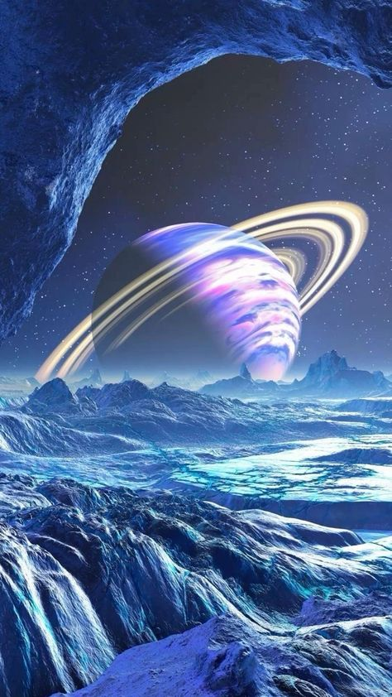

1️⃣ digital art of a space rock with saturn aliens and planets planet in space, in the style of carlos schwabe, light sky-blue and purple, артур скижали-вейс, david nordahl, fictional landscapes, whirly, mesmerizing optical illusions --ar 59:105

2️⃣ abstract space wallpaper & backgrounds space galaxy, in the style of exotic fantasy landscapes, fujifilm eterna vivid 500t, vaporwave, gravity-free scenes, gravity-defying landscapes --ar 59:105

3️⃣ an image of a nebula, with saturns in the sky, in the style of michael whelan, synthwave, saturno butto, celestialpunk, nicholas roerich, cold and detached atmosphere, whirly --ar 59:105

4️⃣ some space based wallpapers, in the style of light violet and sky-blue, ethereal and otherworldly atmosphere, horizons, whirly, ethereal subjects, rim light, synchromism --ar 59:105

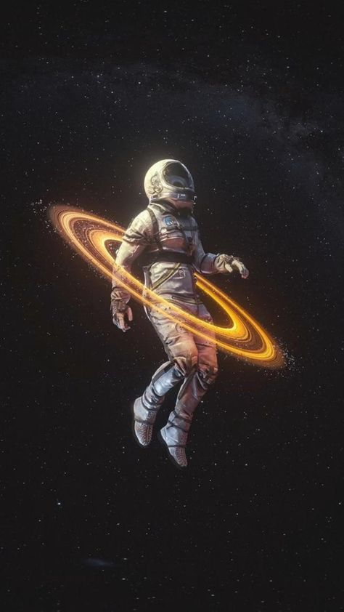

1️⃣ an astronaut flying through a glowing ring, in the style of photo-realistic drawings, graceful balance, furaffinity, whirly, starpunk, heistcore, mottled --ar 59:105

2️⃣ an astronaut flying through space with an orange ring, in the style of photo-realistic drawings, celestialpunk, graceful balance, the stars art group (xing xing), realistic genre scenes, dynamic action scenes --ar 59:105

3️⃣ an astronaut in space with golden rings around his head, in the style of swirling vortexes, realistic depiction of light, animated gifs, graceful balance, peter sculthorpe, the stars art group (xing xing), chalk --ar 59:105

4️⃣ the image of an astronaut in space with a ring in his hand, in the style of swirling vortexes, realistic yet stylized --ar 59:105

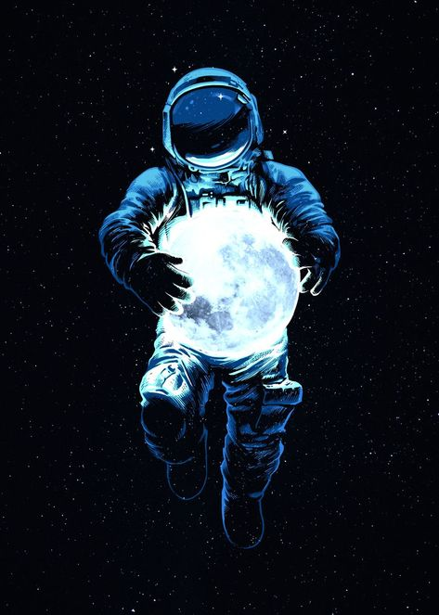

1️⃣ the moon in the stars is shining on the astronaut, in the style of futuristic psychedelia, luminous sfumato, #vfxfriday, contemplative absurdity, light black and blue, celebrity and pop culture references, rotcore --ar 59:82

2️⃣ an astronaut holding a blue full moon in his hands, in the style of sergio toppi, neon realism, kerem beyit, commission for, olafur eliasson, 1970–present, sparklecore --ar 59:82

3️⃣ an astronaut holding a moon, in the style of spacesolarpunk, light black and blue, massurrealism, warmcore, luminous light, reflective, luminous --ar 59:82

4️⃣ an astronaut in space holding a blue moon, in the style of neon realism, celebrity and pop culture references, massurrealism, mcdonaldpunk, tesseract, silhouettes in space, high detail --ar 59:82

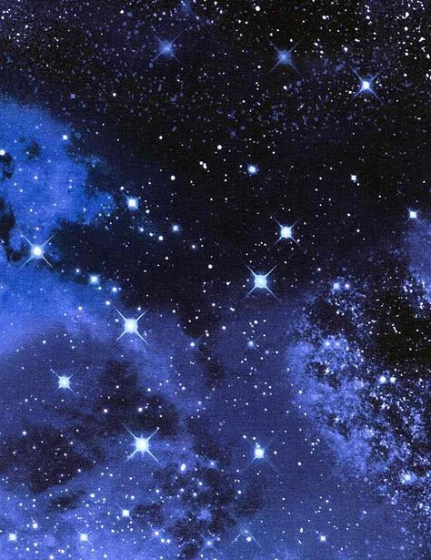

1️⃣ a blue and blue scene of a space with stars in it, in the style of wiccan, sparklecore, ferrania p30, captivating, dreamlike naturaleza, sky-blue and black, celestialpunk --ar 59:76

2️⃣ the stars in a sky look like lights in the night sky, in the style of light indigo and navy, caravaggesque, y2k aesthetic, dreamlike symbolism, light black, ferrania p30, spiritual symbolism --ar 59:76

3️⃣ a galaxy in space with bright blue stars, in the style of wiccan, sparklecore, light indigo and black, atmospheric installations, pretty, flickr, ferrania p30 --ar 59:76

4️⃣ this illustration shows the sky with stars and blue, in the style of sparklecore, wiccan, ferrania p30, indigo and black, pentax k1000, ambitious --ar 59:76

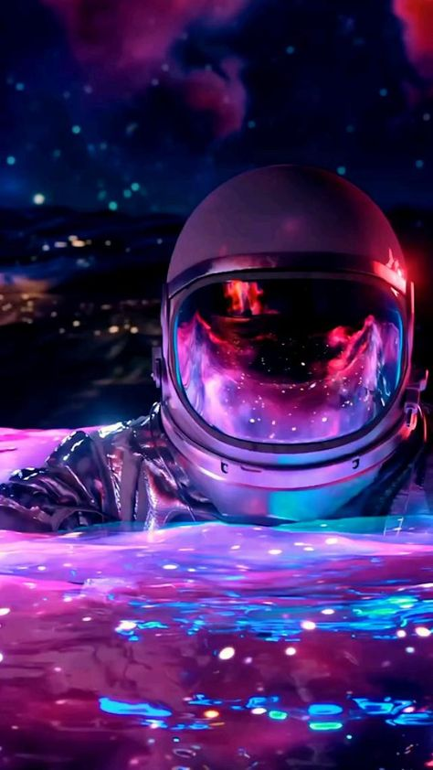

1️⃣ an astronaut in water with a pink light around him, in the style of brandon woelfel, nightcore, panfuturism, animated gifs, the stars art group (xing xing), psychedelic tableaux, made of liquid metal --ar 59:105

2️⃣ an astronaut is in the water with lights on it, in the style of psychedelic vibe, brandon woelfel, nightcore, panfuturism, animated gifs, light crimson and violet, hyper-realistic --ar 59:105

3️⃣ an astronaut floats through the water with a purple light behind him, in the style of kitsch aesthetic, nightcore, video montages, airbrush art, liquid metal, the stars art group (xing xing), experimental videos --ar 59:105

4️⃣ a female astronaut, standing on water with neon lights and pink music, in the style of photo-realistic techniques, nightcore, animated gifs, mysterious and dreamlike scenes, airbrush art, liquid metal, time-lapse photography --ar 59:105

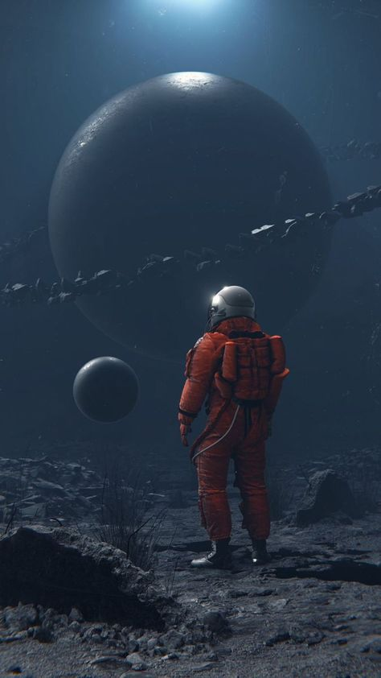

1️⃣ an astronaut in outer space standing near two large moonlike things, in the style of dystopian atmospheres, dark orange and red, hyper-realistic water, animated gifs, monochromatic landscapes, realistic depictions of everyday life, human connections --ar 59:105

2️⃣ an astronaut standing and looking to the large rocky moon, in the style of cyberpunk dystopia, alex alemany, dark red and dark gray, olafur eliasson, realistic depictions of everyday life, frostpunk, schizowave --ar 59:105

3️⃣ an astronaut is standing on the moon looking up at other astronauts, in the style of cyberpunk dystopia, dark crimson and orange, sketchfab, post-apocalyptic backdrops, alex colville, fictional landscapes, realistic scenes --ar 59:105

4️⃣ an astronaut standing in the middle of a stone field, in the style of spatial concept art, dark gray and red, bulbous, realist detail, fictional landscapes, cypherpunk, realistic genre scenes --ar 59:105

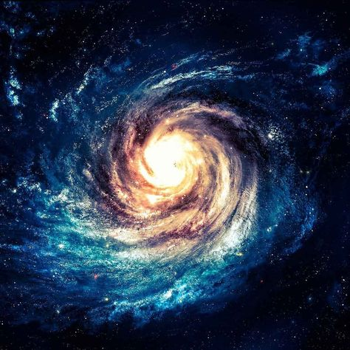

1️⃣ an elaborate spiral galaxy in space, in the style of spiritual symbolism, dark sky-blue and light bronze, light sky-blue and dark white, tinkercore, magewave, metaphysical realism

2️⃣ a colorful swirl in space, in the style of dark sky-blue and light brown, calm and meditative, serenity and calm, atmospheric serenity

3️⃣ a spiral galaxy in space with bright colors, in the style of light sky-blue and dark beige, ethereal symbolism, light white and dark navy, tinkercore, dark sky-blue and dark bronze, exacting precision

4️⃣ a galaxy with stars in the middle, in the style of spirals and curves, dark sky-blue and light beige, terragen, exacting precision, mystical realism, dazecore

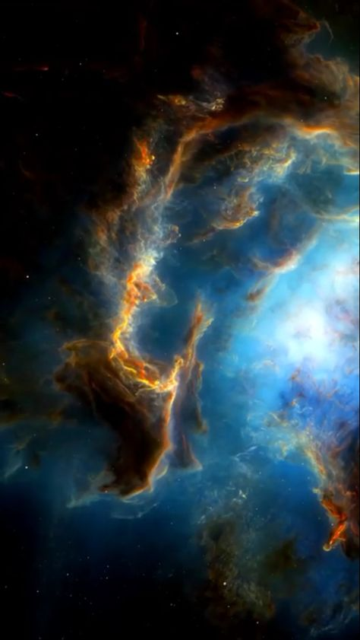

1️⃣ nebula showing the obelisk structure, in the style of marine biology-inspired, cinematic montages, rubens, cinematic sets, glorious, azure and amber, ue5 --ar 59:105

2️⃣ a photo of an enormous nebula with blue stars, in the style of colorful animation stills, marine biology-inspired, fluid formation, light black and orange, willem claesz. heda, psychedelic surrealism:, light crimson and sky-blue --ar 59:105

3️⃣ celestial nebula as seen from space, in the style of unreal engine 5, dreamy symbolism, rubens, 32k uhd, polished metamorphosis, cinematic sets --ar 59:105

4️⃣ this image shows the nebula with blue and green cloudy clouds, in the style of cinematic sets, hyacinthe rigaud, rollerwave, orange and blue, 32k uhd, tony orrico, john howe --ar 59:105

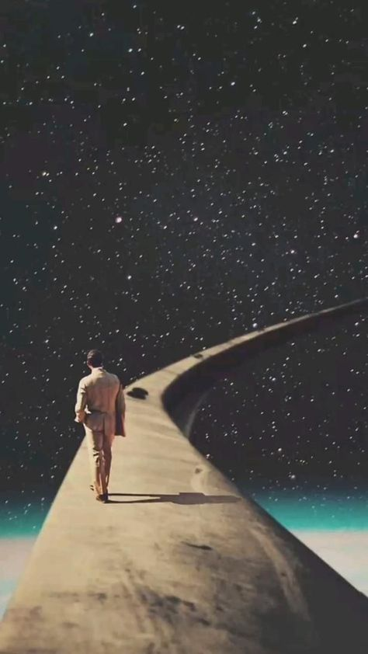

1️⃣ the man walking down a road with stars above him, in the style of #film, animated gifs, surrealist realist, paolo soleri, die brücke, dreamy and romantic, oscar niemeyer --ar 59:105

2️⃣ a man walking along a road in the space with stars, in the style of #film, enchanting surrealism, die brücke, animated gifs, realistic yet romantic, thought-provoking, iconic --ar 59:105

3️⃣ there is a man walking on an open road in space, in the style of soft and dreamy depictions, die brücke, movie still, enchanting, animated gifs, snapshots of iconic hollywood stars, escher-inspired --ar 59:105

4️⃣ a man walking down a path with the moon behind him, in the style of animated gifs, cosmic, oscar niemeyer, soft, dreamy scenes, movie still, dream-like scenes, antoni gaudí --ar 59:105

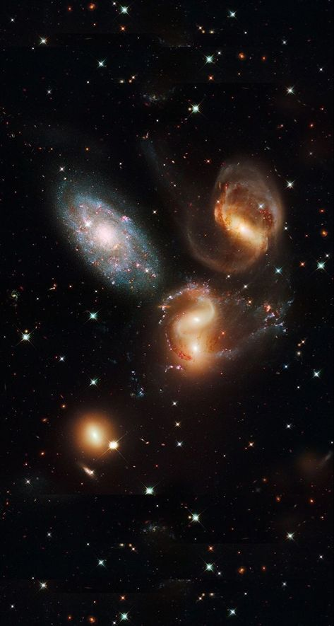

1️⃣ four galaxies shining red at black background, in the style of light teal and light orange, photomontage, pictorial space, alex timmermans, mike kelley, pristine naturalism, focus on joints/connections --ar 59:110

2️⃣ a group of galaxies from all angles, in the style of exquisite animalism, pleasing sense of harmony, whiplash curves, associated press photo, otherworldly creatures, sparklecore --ar 59:110

3️⃣ five different galaxies in the starry sky, in the style of philippe halsman, light aquamarine and orange, creative commons attribution, focus on joints/connections, sparklecore, aerial photography, baroque energy --ar 59:110

4️⃣ two large and large galaxies as they appear from behind, in the style of semiotic realism, emotionally complex, pleasing sense of harmony, otherworldly creatures, group f/64, sparklecore, otherworldly realism --ar 59:110

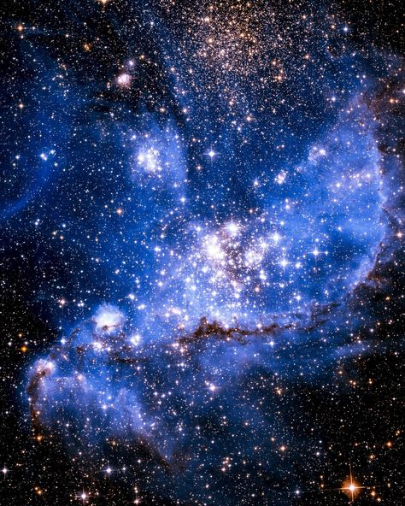

1️⃣ a blue, blue cluster with a blue star attached, in the style of dark sky-blue and white, writer academia, ethereal, dreamlike quality, nyc explosion coverage, pseudo-infrared, magewave, dark black and sky-blue --ar 59:74

2️⃣ scorpius nebula, an octogram, the blue structure of light in space, in the style of nyc explosion coverage, ambiguous space --ar 59:74

3️⃣ big bang galaxy image, in the style of sky-blue and black, elaborate spacecrafts, precisionism influence, dramatic, somber religious works, sparklecore, explosive pigmentation, yankeecore --ar 59:74

4️⃣ the white mottle nebula, in the constellation constellation umut, in the style of dark aquamarine and sky-blue, radiant clusters, david wojnarowicz, dreamy symbolism, nyc explosion coverage, magewave, sparklecore --ar 59:74

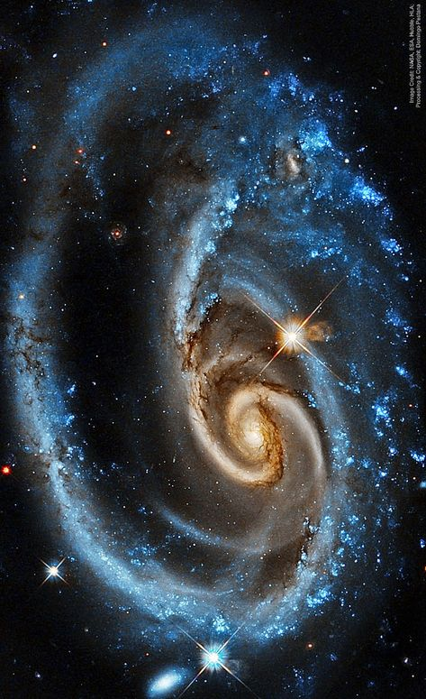

1️⃣ a spiral galaxy containing stars and star clusters, in the style of light orange and dark aquamarine, sense of quiet contemplation, emotional resonance, fantastic creatures, contemplative atmospheres --ar 59:96

2️⃣ a spiral galaxy with stars, in the style of light orange and dark aquamarine, exacting precision, otherworldly, sparklecore --ar 59:96

3️⃣ spiral galaxies hd wallpapers, in the style of dark amber and sky-blue, associated press photo, blink-and-you-miss-it detail, hurufiyya, exquisite animalism, elaborate spacecrafts, symbolic overload --ar 59:96

4️⃣ a spiral galaxy is shown in the blue light, in the style of light orange and dark aquamarine, spirals and curves, blink-and-you-miss-it detail, patricia piccinini, raymond swanland, hurufiyya, nyc explosion coverage --ar 59:96

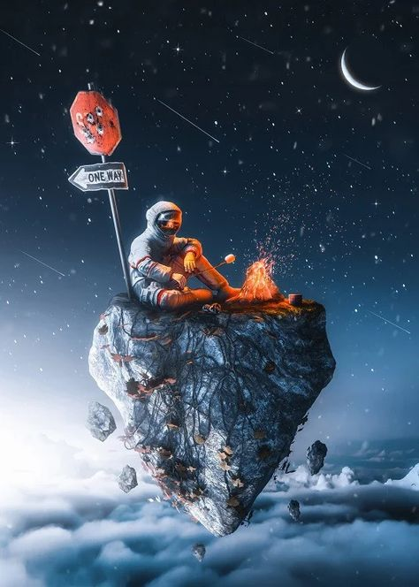

1️⃣ a little man with a rocket on top of a rock at night, in the style of realism with surrealistic elements, snow scenes, the stars art group (xing xing), comfycore, silver and orange, photorealistic scenes, surreal comic scenes --ar 59:83

2️⃣ moon, sea, lights, clouds, astronaut and rocks illustrative abstract scene, 4k wallpaper, 3d sky, photoshop, in the style of street art graffiti-inspired, snow scenes, the stars art group (xing xing), action paintings, dark gray and red, tabletop photography, intuitive gestures --ar 59:83

3️⃣ a man sits on top of a rock on a lonely island, in the style of cosmic graffiti, realism with fantasy elements, the stars art group (xing xing), silver and orange, snow scenes, anatoly metlan, joram roukes --ar 59:83

4️⃣ a spacer sitting on an island surrounded by clouds, in the style of energetic street artist, fantasy illustrations, grzegorz domaradzki, dark silver and red, the stars art group (xing xing victor nizovtsev, cold and detached atmosphere --ar 59:83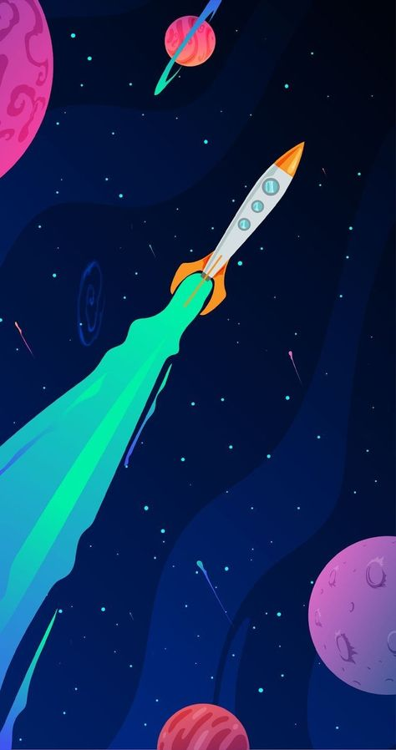

1️⃣ the image shows a rocket flying above the stars and planets, in the style of light teal and magenta, biomorphic, ambitious, animated gifs, commission for, poster, colorful drawings --ar 59:112

2️⃣ a rocket flying through space with several planets on other planets, in the style of light teal and magenta, biomorphic, studyblr, toonami, handheld, illuminated manuscript-esque, animated gifs --ar 59:112

3️⃣ image of astronomical rocket flying near planets, in the style of light teal and magenta, animated illustrations, vibrant murals, narrative-driven visual storytelling, datamosh, #screenshotsaturday, light emerald and dark blue --ar 59:112

4️⃣ ship on space exploration space background emily emily design, in the style of colorful animations, light blue and emerald, colorful drawings, long lens, james nares, lo-fi aesthetics, use of bright colors --ar 59:112

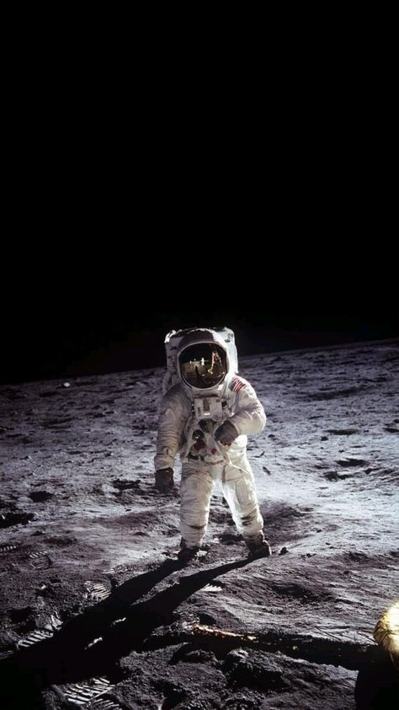

1️⃣ a man in space suit wearing a white helmet and glasses is standing on the moon, in the style of i can't believe how beautiful this is, 1970–present --ar 59:105

2️⃣ astronaut earthling standing on the moon, in the style of celebrity photography, historical subjects, traditional, dark white and light black --ar 59:105

3️⃣ an astronaut is standing on the moon, in the style of 1970–present, full body --ar 59:105

4️⃣ the first person ever to walk on the moon, in the style of strong contrast, chiaroscuro, spectacular backdrops, distinctive noses, dark white and silver, iconic, dusty piles, 1960s --ar 59:105

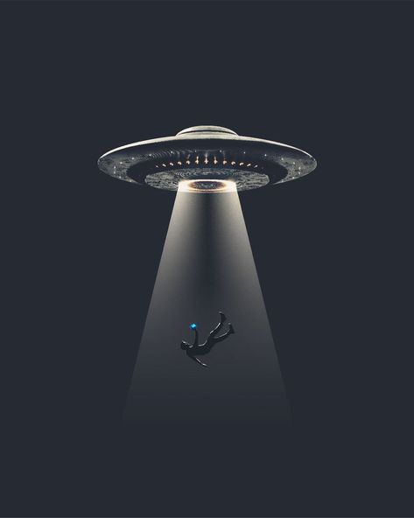

1️⃣ ufo flight ufo flight flying in deep space and guiding someone to their landing spot, in the style of grégoire guillemin, petros afshar, cerith wyn evans, spiritualcore, technology-based art, i can't believe how beautiful this is, light black and gray --ar 59:74

2️⃣ an alien spaceship floats on a dark background, in the style of security camera art, spontaneous gesture, #film, minimalist stage designs, realistic lighting, caricature-like illustrations, suspended/hanging --ar 59:74

3️⃣ floating in the dark near a glowing alien spaceship, in the style of minimalist stage designs, grégoire guillemin, patricia piccinini, light gray and black, banksy, concept art, celestialpunk --ar 59:74

4️⃣ aliens coming from behind light from alien spaceship, in the style of graphic design-inspired illustrations, forced perspective, the stars art group (xing xing), clever juxtapositions, light black and azure, surprisingly absurd, iconic civil rights imagery --ar 59:74

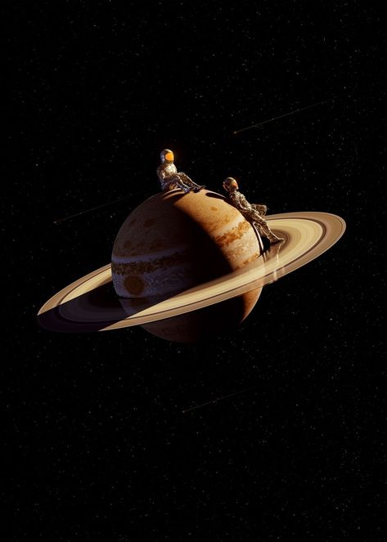

1️⃣ a couple riding around saturn, in the style of photorealistic pastiche, celestialpunk, dark beige and amber, infinity nets, flattened perspective, the new fauves, aerial photography --ar 59:82

2️⃣ astronauts travelling on saturn, in the style of peter sculthorpe, linnea strid, celestialpunk, jean-léon gérôme, meticulously detailed, light amber, dieselpunk --ar 59:82

3️⃣ two men riding a spaceship on saturn, in the style of alessio albi, light gold and amber, precise hyperrealism, ue5, david nordahl, transportcore, aerial view --ar 59:82

4️⃣ one planet on a planet on top of it, in the style of dieselpunk, dark white and light amber, captivating figures, vray, caravaggesque, transportcore, celestialpunk --ar 59:82

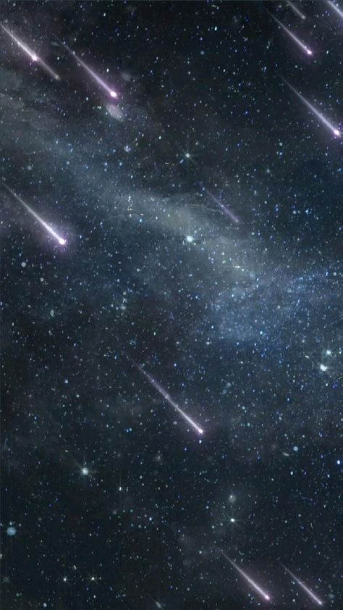

1️⃣ many small comets flash in the night sky, in the style of precisionism influence, dark aquamarine, nyc explosion coverage, explosive pigmentation, american barbizon school, furaffinity, blurred imagery --ar 59:105

2️⃣ some lightning stars and meteors are flying in the sky, in the style of boldly fragmented, ue5, 20 megapixels, unearthly --ar 59:105

3️⃣ a large group of stars in space, in the style of camera tossing, dark gray and sky-blue, claire-obscure lighting, nyc explosion coverage, animated gifs, carlos schwabe, jan van kessel the elder --ar 59:105

4️⃣ hula rocket catches fireworks in space, in the style of pictorialism influence, cosmic imagery --ar 59:105

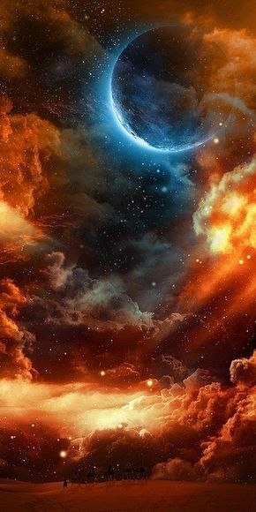

1️⃣ a space image of an orange moon and an orange planet, in the style of ethereal cloudscapes, dark crimson and blue, tesseract, swirling vortexes, mysterious backdrops, the stars art group (xing xing), symbolist themes --ar 1:2

2️⃣ the scene that shows the sky with all colors, in the style of imaginative spacescapes, dark orange and light blue, celestialpunk, warmcore, epic fantasy scenes, cosmic themes, jake wood-evans --ar 1:2

3️⃣ the sun with moon and clouds in the background, in the style of dark matter art, dark aquamarine and orange, caras ionut, chaotic environments, raymond swanland, expansive, shot on 70mm --ar 1:2

4️⃣ a moon in the sky with clouds and a large cloud, in the style of dark orange and dark aquamarine, cosmic horror, the stars art group (xing xing), warmcore, post-apocalyptic backdrops, celestialpunk, swirling vortexes --ar 1:2

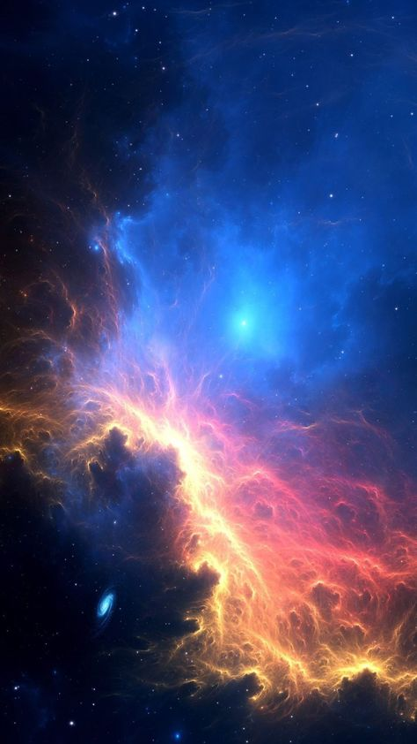

1️⃣ blue red and yellow nebula in space, in the style of unreal engine 5, spectacular backdrops, paul barson, mystical themes, mystical theme, dark pink and sky-blue --ar 59:105

2️⃣ space wallpapers nebulas space wallpapers, in the style of realistic usage of light and color, dark pink and azure, dark orange and sky-blue, unreal engine 5, mystical themes, radiant clusters --ar 59:105

3️⃣ the nebula that appears in space, in the style of photobashing, space art --ar 59:105

4️⃣ a beautiful blue, red and blue background pattern in space, in the style of tenebrism mastery, swirling vortexes --ar 59:105

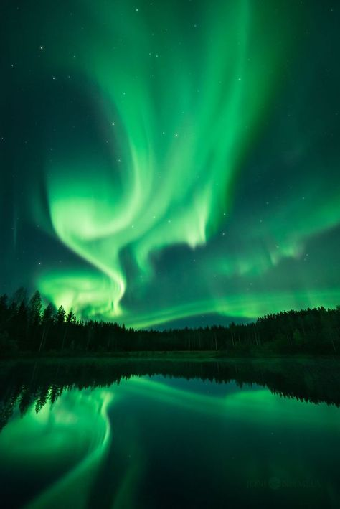

1️⃣ the green northern lights are reflecting off a lake in northern finland, in the style of swirling vortexes, dark sky-blue and light beige, weathercore, stimwave, magali villeneuve, archillect --ar 59:88

2️⃣ a forest is reflected in the lake with the northern lights in the sky, in the style of swirling vortexes, weathercore, light green and dark emerald, the anthropocene, warmcore, the helsinki school, mystic symbolism --ar 59:88

3️⃣ a green aurora borealis hanging over a dark lake, in the style of nature-based patterns, dimitry roulland, the helsinki school, cosmic themes, weathercore --ar 59:88

4️⃣ an aurora and a rainbow over a body of water, in the style of dark green and light green, mind-bending patterns, the helsinki school, warmcore, mystical realms, the stars art group (xing xing), fleeting moments --ar 59:88

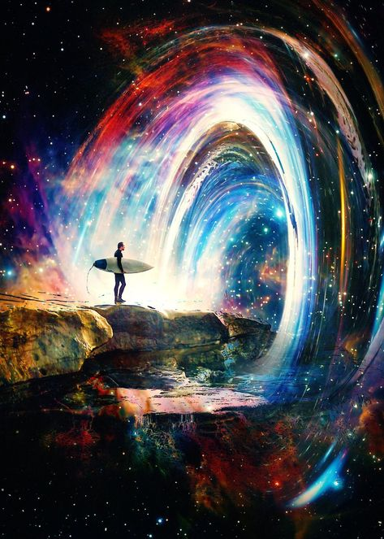

1️⃣ a surfer stands in front of a big spiral galaxy, in the style of colorful storytelling, transcendental art, magewave, glistening, dreamy collages, fluid gestures, dreamlike figures --ar 59:82

2️⃣ surfer in space with star swirling around him, in the style of enchanting realms, dreamlike installations, multilayered dimensions, firecore, colorful storytelling, mesmerizing optical illusions, flickr --ar 59:82

3️⃣ image of a surfer surfed across a spacetime tunnel, in the style of cosmic symbolism, technicolor dreamscape, magewave, i can't believe how beautiful this is, rotcore, sui ishida, alexander jansson --ar 59:82

4️⃣ the surfer is in the center of a giant spacecraft and the waves go around him, in the style of technicolor dreamscape, transcendental art, flickr, cosmic symbolism, firecore, whirly, light-filled --ar 59:82

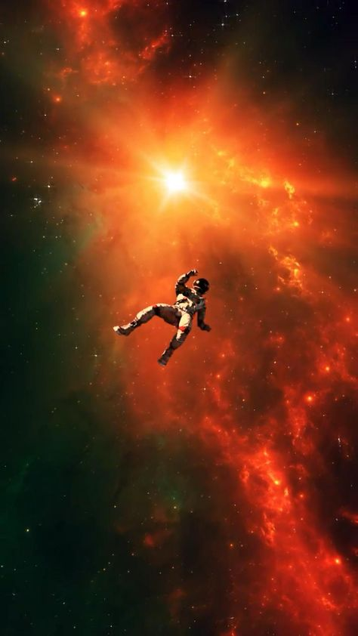

1️⃣ a man floating in space in the middle of a nebula with stars, in the style of dark orange and dark emerald, post-apocalyptic backdrops, i can't believe how beautiful this is, rtx on, surrealism-inspired, marat safin, snapshots of iconic hollywood stars --ar 59:105

2️⃣ a human flying in space with glowing stars, in the style of post-apocalyptic backdrops, dark orange and maroon, i can't believe how beautiful this is, photobashing, mort künstler, solarizing master, furaffinity --ar 59:105

3️⃣ someone in space amidst glowing stars, in the style of dark orange and dark emerald, dynamic action scenes, glorious, #film, spectacular backdrops, rubens, solarizing master --ar 59:105

4️⃣ a woman floating through the universe with an object, in the style of dark red and dark orange, impressive skies, rtx on, photo-realistic, spacesolarpunk, spectacular backdrops, commission for --ar 59:105

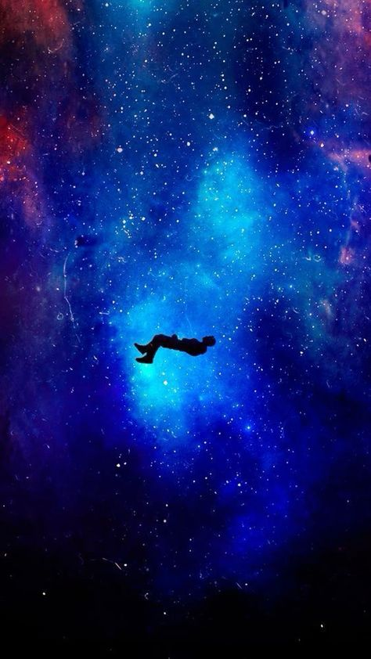

1️⃣ a person floating in an empty blue space, in the style of cosmic themes, transcendentalist themes, celestialpunk --ar 59:105

2️⃣ the person's body is in space, in the style of dreamy symbolism, dark sky-blue and black, unconventional poses, flickr, colorful absurdism, sfumato, transcendentalist themes --ar 59:105

3️⃣ a male flying through the night sky, in the style of surrealist subconsciousness, furaffinity, dark sky-blue and dark maroon, keith carter, the stars art group (xing xing), helio oiticica, cosmic inspiration --ar 59:105

4️⃣ the man in the spaceship is floating in space, in the style of dark sky-blue and dark maroon, joel robison, john buscema, photo taken with provia, vibrant metaphysical, warmcore, duy huynh --ar 59:105

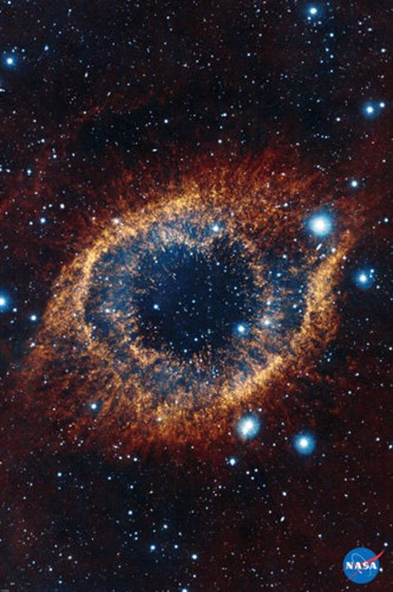

1️⃣ the ring nasa image, in the style of the stars art group (xing xing), captivating gaze, explosive pigmentation, shiny eyes, magewave, weirdcore --ar 59:88

2️⃣ the ring in space, in the style of intense gaze, felicia simion, mandy disher, aquirax uno, dark cyan and orange, distinctive noses, magewave --ar 59:88

3️⃣ the iris nasa's telescope, taken in 2000, in the style of interstellar nebulae, dark turquoise and orange, bloomcore, sparklecore, circular shapes, tesseract, wandering eye --ar 59:88

4️⃣ kafatype ring at the planet dcs1, in the style of dan witz, vivid dreamscapes, cosmic imagery --ar 59:88

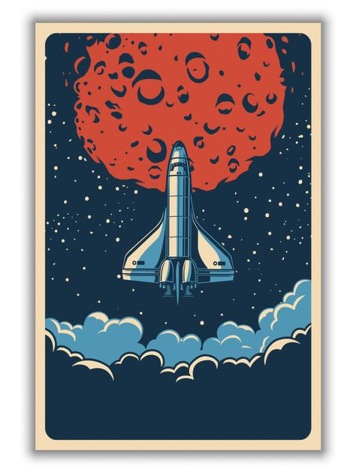

1️⃣ space shuttle poster retro retro poster poster by gilove, in the style of light indigo and red, luxurious wall hangings, iconic rock and roll imagery, 3840x2160, whimsical dreamscapes, energy-filled illustrations, concert poster --ar 59:78

2️⃣ a space shuttle landing framed print with a view of outer space, in the style of butcher billy, 3840x2160, ravi zupa, graphic design-inspired illustrations, light indigo and red --ar 59:78

3️⃣ it is an illustration on paper with the red saturn shuttle on it in space, in the style of dark sky-blue and light bronze, bold posters, iconic rock and roll imagery, 1970–present, lunarpunk, panoramic scale --ar 59:78

4️⃣ a space shuttle traveling across the sky with moon, in the style of butcher billy, light red and light indigo, luxurious wall hangings, 3840x2160, kerem beyit, concert poster, james jean --ar 59:78

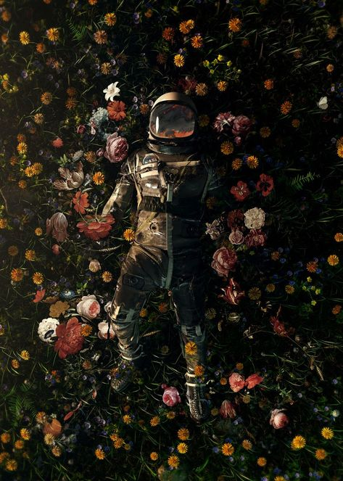

1️⃣ a spacesuit, floating in a field of flowers, in the style of dark compositions, photorealistic accuracy, immersive, grid-based, earthy palettes, celestial, made of flowers --ar 59:82

2️⃣ an astronaut laying in the flowers, with the sun behind him, in the style of jamie baldridge, unreal engine 5, brad kunkle, casts of spaces, alan bean, installation-based, dark colors --ar 59:82

3️⃣ an astronaut sits among flowers, in the style of hyper-realistic atmospheres, gravity-free scenes, captivating documentary photos, dark green and dark gold, hyper-realistic sci-fi, aerial photography, rtx on --ar 59:82

4️⃣ this poster shows space aliens in the flower field, in the style of captivating documentary photos, dark and chaotic, national geographic photo, unreal engine 5, made of flowers, full body, uniformly staged images --ar 59:82

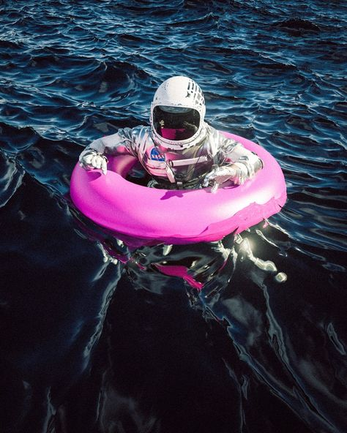

1️⃣ astronaut in the ocean floating pink pool toy, in the style of misha gordin, rollerwave, adventurecore, site-specific, kurzgesagt, leander engström, realist: lifelike accuracy --ar 59:74

2️⃣ an astronaut is floating in the ocean on a pink inflatable ring, in the style of zeiss otus 85mm f/1.4 apo planar t*, hyperrealist, duckcore, photo taken with provia, outrun, realist: lifelike accuracy, alasdair mclellan --ar 59:74

3️⃣ an astronaut riding a pink fin on the water, in the style of noise photography, hyperrealist, zeiss milvus 25mm f/1.4 ze. --ar 59:74

4️⃣ a woman wearing her astronaut outfit floating in the ocean, in the style of light black and magenta, transportcore, iso 200, exacting precision, duckcore, konica auto s3, creased --ar 59:74

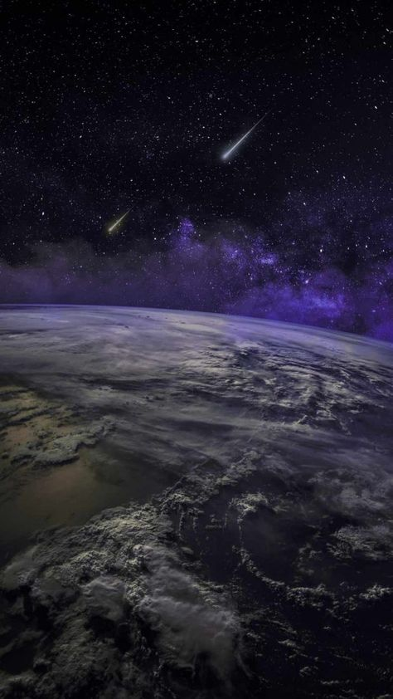

1️⃣ a view of planet earth and comets from space, in the style of purple and gray, dreamy realism, immersive environments, weathercore, photorealistic pastiche, the stars art group (xing xing), poignant --ar 59:105

2️⃣ comets above the earth art print, in the style of dramatic atmospheric perspective, unreal engine 5, light black and violet, time-lapse photography and film, hyperrealistic environments, the stars art group (xing xing), mottled --ar 59:105

3️⃣ ufos have an official view of the sun from the earth as it stretches across the universe, in the style of purple and gray, stormy seascapes, photorealistic renderings, the stars art group (xing xing), light purple and dark gray, uhd image, cosmic landscape --ar 59:105

4️⃣ a spacecraft is seen from the earth, in the style of swirling vortexes, light black and violet, atmospheric perspectives, atmospheric clouds, eugene tertychnyi, impressive panoramas, realistic chiaroscuro --ar 59:105

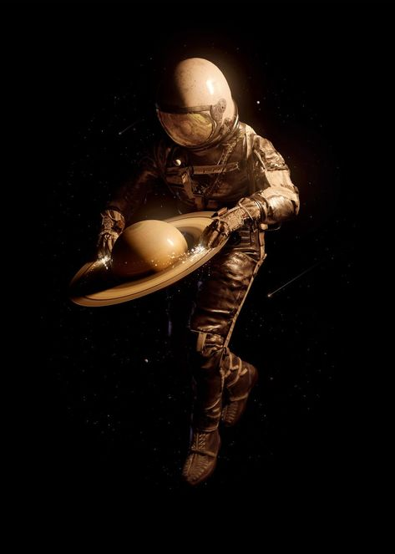

1️⃣ an astronaut holding an saturn around its neck, in the style of realistic chiaroscuro, rtx on, the new fauves, cyclorama, realistic, commission for, utilitarian --ar 59:82

2️⃣ astronaut in space, holding a saturn, in the style of zbrush, realist chiaroscuro, peter sculthorpe, luke fildes, the new fauves, utilitarian, realistic portrayals --ar 59:82

3️⃣ the astronaut holding a saturn dish, in the style of zbrush, realist chiaroscuro, mcdonaldpunk, light black and bronze, uniformly staged images, cargopunk, dynamic action scenes --ar 59:82

4️⃣ an astronaut in space holding an object, in the style of dark black and bronze, photorealistic fantasies, mcdonaldpunk, zbrush, frostpunk, installation-based, graceful balance --ar 59:82

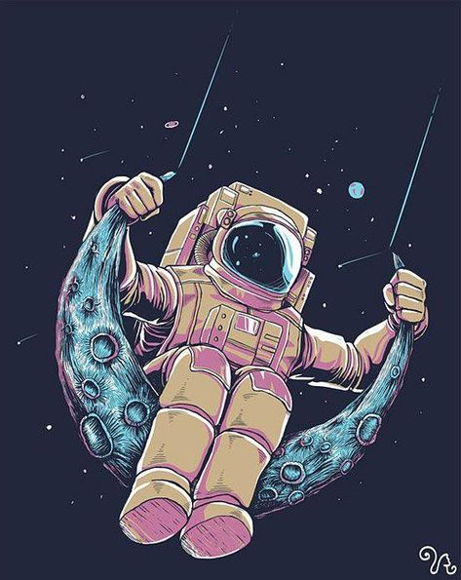

1️⃣ a cartoon drawing of an astronaut flying on the moon, in the style of light teal and dark pink, fantastic realism, screen printing, i can't believe how beautiful this is, symmetry and balance, anemoiacore, solarizing master --ar 59:74

2️⃣ an astronaut sitting on a moon hanging on the edge of a ring, in the style of light teal and light magenta, vibrant comics, transfer, ambitious, i can't believe how beautiful this is, elaborate spacecrafts, balance and harmony --ar 59:74

3️⃣ an astronaut sitting on the moon, in the style of light teal and light magenta, playful and fun imagery, transfer, ambitious, i can't believe how beautiful this is, comiccore, suspended/hanging --ar 59:74

4️⃣ a man is wearing an ear cover and flying about on a moon, in the style of light teal and pink, space art, mono-ha, inventive character designs, balance, i can't believe how beautiful this is, playful and colorful depictions --ar 59:74

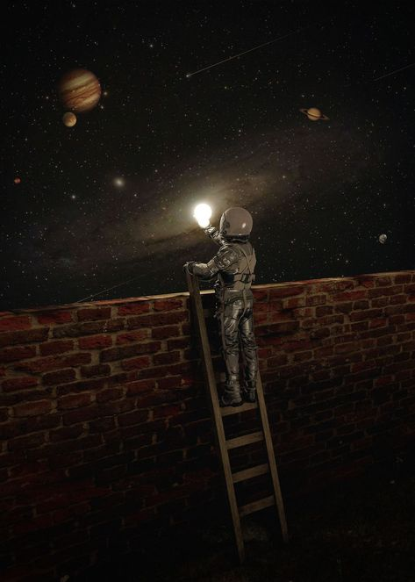

1️⃣ an astronaut is leading a ladder to look out over the planets, in the style of surrealistic installations, photo-realistic, chiaroscuro portraitures, surrealistic dreamscapes, conceptual street art, texture exploration, realistic depiction of light --ar 59:82

2️⃣ an image of an astronaut reaching up on a metal ladder through the space, in the style of aron wiesenfeld, adrian donoghue, nightscape, flickr, m.c. escher, installation-based, bulbous --ar 59:82

3️⃣ artist portrait astronaut with a lantern on a ladder in outer space by anoee, in the style of aron wiesenfeld, varying perspectives, flickr, perspective rendering, saurabh jethani, alien worlds, installation creator --ar 59:82

4️⃣ space painting digital painting astronaut to planetary system, in the style of trompe l'oeil illusions, urban exploration, flickr, realistic chiaroscuro lighting, found objects, museum gallery dioramas, dusty piles --ar 59:82

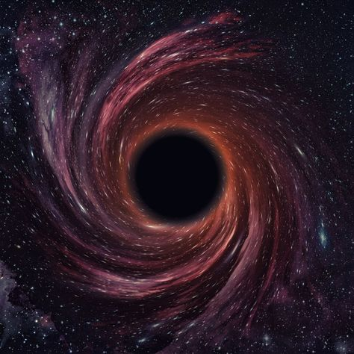

1️⃣ black hole is one of the main reasons why cosmology is important, in the style of filip hodas, dark teal and dark red, intel core, black and white mastery, dark orange and pink, precisionist style, playful absurdity

2️⃣ this image shows a giant black hole in space, in the style of mysterious realism, dark aquamarine and crimson, swirling vortexes, intel core, mysterious symbolism, pointillist optical illusions, light orange and purple

3️⃣ black hole in space and time, in the style of precisionism influence, mysterious atmospheres, mysterious atmosphere

4️⃣ black hole in nasa's distant universe, in the style of psychedelic surrealism:, rollerwave, dark aquamarine and crimson, intel core, mysterious symbolism, spiral group, mottled

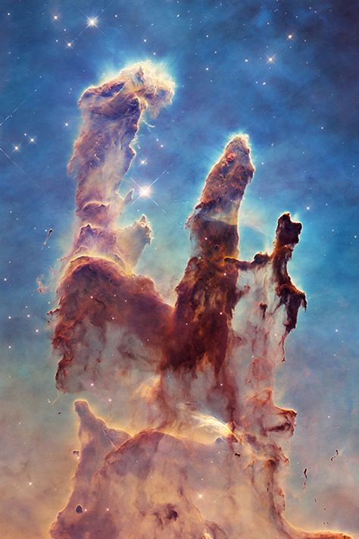

1️⃣ an image of a huge star formation, in the style of ethereal sculptures, science-fiction lands, colorful washes, distinctive noses, karol bak, spontaneous gesture, impressive skies --ar 59:88

2️⃣ a beautiful image of the egypt nebula is shown, in the style of sculptural surrealism, spontaneous gesture, robert hagan, organic formations, monochromatic masterpieces, casts of spaces, dreamlike architecture --ar 59:88

3️⃣ the eingean cloud formation in nasa, space, in the style of surreal animal hybrids, spontaneous gesture, the stars art group (xing xing), dusty piles, mesmerizing colorscapes, distinctive noses, fluid gestures --ar 59:88

4️⃣ nasa s nebula egcdel nebula spired stars, in the style of surreal architectural landscapes, spontaneous gesture, imagined worlds, surreal animal hybrids, rubens, the stars art group (xing xing), distinctive noses --ar 59:88

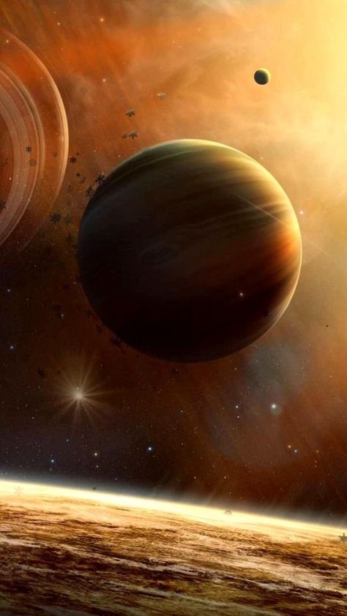

1️⃣ a planet in an outer space, in the style of light bronze and light amber, science-fiction dystopias, spacecore, stimwave, nostalgiacore, firecore, raymond swanland --ar 59:105

2️⃣ a computergenerated atmosphere in space with some planets and stars, in the style of light brown and light amber, ashcan school, hyper-realistic oil, swirling vortexes, havencore, magewave, group f/64 --ar 59:105

3️⃣ three planets above the planet with orbiter around them, in the style of light yellow and dark amber, soft edges and atmospheric effects, bugcore, heistcore, ue5, whistlerian, swirling vortexes --ar 59:105

4️⃣ a bright sun and planets appear above the earth, in the style of mysterious atmospheres, tenwave, saturno butto, ben wooten, rough clusters, dusan djukaric, havencore --ar 59:105

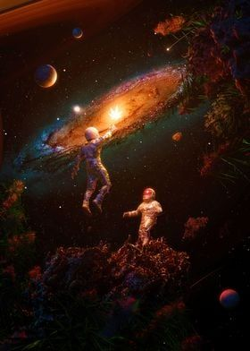

1️⃣ two astronauts are outside in the galaxy, in the style of larry carlson, jessica drossin, immersive, saturno butto, gigantic scale --ar 5:7

2️⃣ two in space with a galaxy and an earth, in the style of distorted and exaggerated human figures, vray tracing, glimmering light effects, psychedelic surrealism:, album covers, i can't believe how beautiful this is, firecore --ar 5:7

3️⃣ the art of exploration the galaxy, in the style of steve hillier, dreamlike figures, mike campau, cosmic --ar 5:7

4️⃣ an illustration of a scientist holding an alien with solar winds blowing around him, in the style of kodak aerochrome iii infrared, the stars art group (xing xing), rendered in unreal engine, surreal human figures, photo taken with provia, xbox 360 graphics, high-angle --ar 5:7

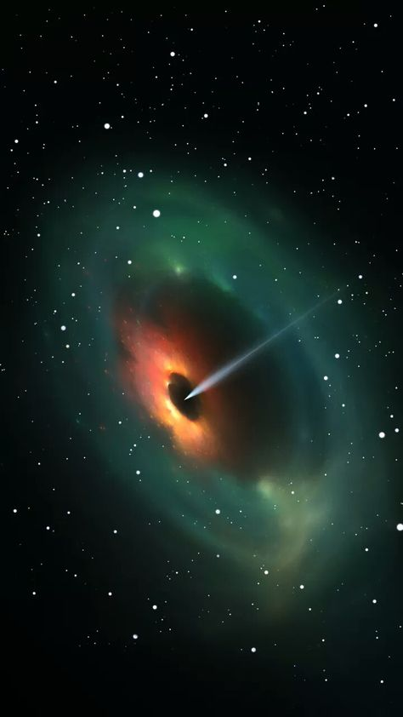

1️⃣ a black hole with some light coming out of it, in the style of light emerald and orange, sung kim, dan matutina, saturno butto, i can't believe how beautiful this is --ar 59:105

2️⃣ a black hole moving around in space, in the style of dark aquamarine and orange, wetcore, dark emerald and red, bombacore, aurorapunk, light academia, soft-edged --ar 59:105

3️⃣ a black hole surrounded by stars and planets, in the style of light emerald and red, feralcore, toyo ito, dan witz, photobashing, constantin brancusi, i can't believe how beautiful this is --ar 59:105

4️⃣ the black hole in space, in the style of dark aquamarine and light amber, weirdcore, bombacore, i can't believe how beautiful this is, realistic yet stylized, camera tossing, dark green and red --ar 59:105

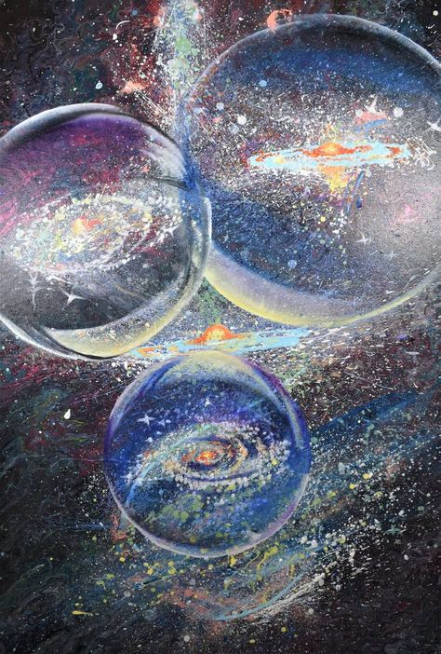

1️⃣ acrylic painting of a painting of bubbles in the galaxy, in the style of illusion of three-dimensionality, intense close-ups, jon foster, aerial view, multiple points of view, carolyn blish, multilayered realism --ar 59:87

2️⃣ a drawing of a galaxy with three bubbles in it, in the style of jon foster, vibrant glasswork studies, aerial view, carolyn blish, mesmerizing optical illusions, optical illusion paintings, intense close-ups --ar 59:87

3️⃣ three paintings of stars, with the galaxy around them, in the style of luminous spheres, mixed media surrealism, sparkling water reflections, marbleized, birds-eye-view, otherworldly fun, mesmerizing optical illusions --ar 59:87

4️⃣ a bright painting with three bubbles in it, in the style of imaginative spacescapes, trick of the eye paintings, intense close-ups, celestialpunk, hyperrealistic paintings, chalk and charcoal printing, multilayered realism --ar 59:87

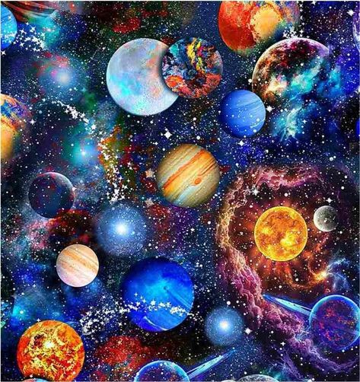

1️⃣ a beautiful design of all the planets with stars, in the style of collage frenzy, mesmerizing colorscapes, firecore, y2k aesthetic, mottled, radiant colors, utopian vision --ar 59:62

2️⃣ cosmic space planets pattern fabric for quilting, sewing projects, in the style of spectacular backdrops, perceptive, collage-based --ar 59:62

3️⃣ the solar system planets painting, in the style of rodel gonzalez, pattern explosion, colorful fantasy realism, john buscema, greg olsen, colorful collage, y2k aesthetic --ar 59:62

4️⃣ a photo of the universe with seven planets, in the style of lisa frank, light navy and red, kinuko y. craft, repetitive, gemstone, john buscema, gossamer fabrics --ar 59:62

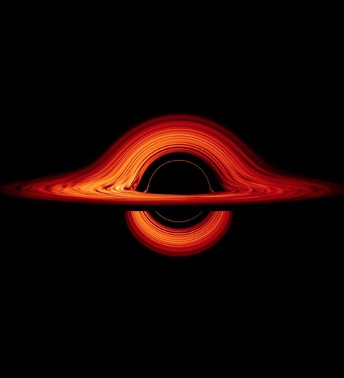

1️⃣ galaxy rings nasa images, in the style of neo-geo minimalism, dark black and orange, rollerwave, realistic depiction of light, duckcore, i can't believe how beautiful this is, crimson and black --ar 59:65

2️⃣ an image of a galaxy with fiery rings, in the style of neo-geo minimalism, dark orange and black, george digalakis, rollerwave, distorted form, i can't believe how beautiful this is, open form --ar 59:65

3️⃣ a black background is shown along with an orange star/salary ring, in the style of colorful turbulence, flatness of surface, rim light, dark red and black, tumblewave, science-fiction lands, iconic --ar 59:65

4️⃣ galaxy disk in the universe, in the style of dark orange and dark black, sinuous lines, rollerwave, precisionist style, john pawson, high resolution, dark black and crimson --ar 59:65

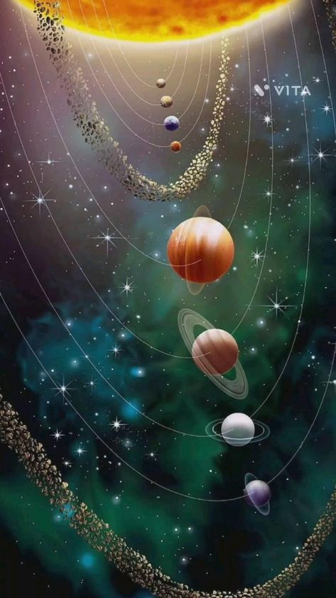

1️⃣ a planet with several other planets, in the style of dreamy symbolism, celestialpunk, the stars art group (xing xing) --ar 59:105

2️⃣ planets, stars and the solar system with the sun in the middle, in the style of the stars art group (xing xing), light green and light brown, mysterious backdrops, y2k aesthetic, dark aquamarine and red, spiral group, illusion of three-dimensionality --ar 59:105

3️⃣ an illustration showing the solar system with suns and planets, in the style of dreamy collages, light emerald and maroon, lee bogle, grandeur of scale, y2k aesthetic, spiral group, use of precious materials --ar 59:105

4️⃣ poster for a science fiction wall art, with the planets in space, in the style of caravaggesque, spectacular backdrops, gossamer fabrics, 3840x2160, balance and harmony, massurrealism, spiral group --ar 59:105

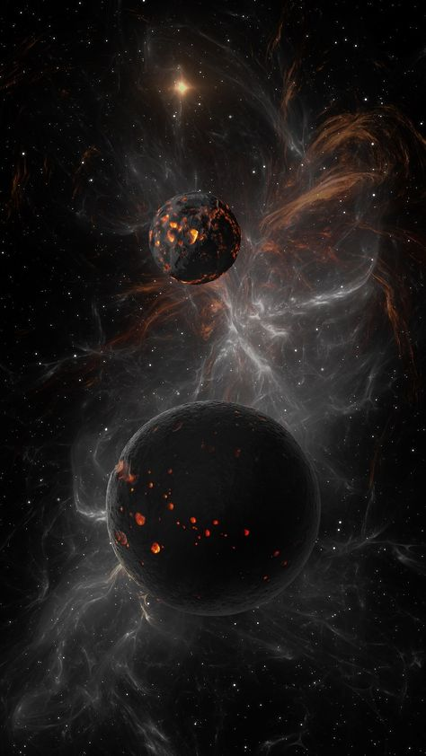

1️⃣ swarm of black holes in nasa outer space, in the style of dark amber and gray, eroded surfaces, raynald leclerc, monia merlo, luminous spheres, tinkercore, burned/charred --ar 59:105

2️⃣ two small brown dwarfs are in a star field, in the style of explosive expressionism, sketchfab, burned/charred, luminous spheres, vibrant chaos, black and white imagery, zbrush --ar 59:105

3️⃣ b gyr stars have reached new heights of lightening and atomic fusion, in the style of science fiction art, dark black and orange, eroded surfaces, sketchfab, uhd image, luminous spheres, fantasy worlds --ar 59:105

4️⃣ if a dwarf planet forms, its gravitational pull sways the axis of rotation, in the style of abstract expressionist explosions, unreal engine, orange and black, perry rhodan, burned/charred, luminous spheres, apocalypse art --ar 59:105

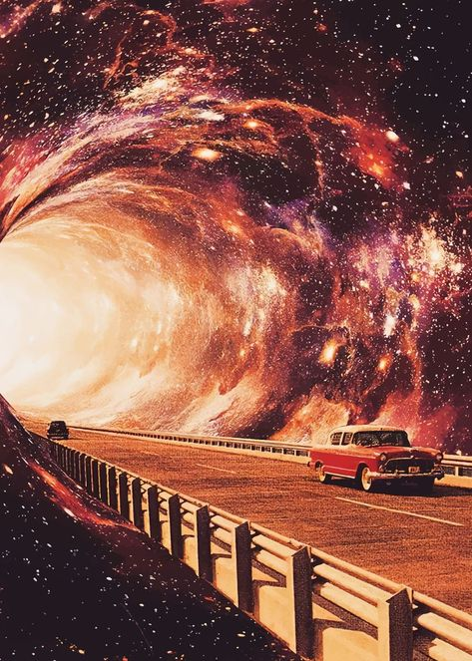

1️⃣ a man driving in a red car on a road near a tunnel with stars, in the style of surreal collages, interstellar nebulae, casey weldon, impressive panoramas, magewave, #vfxfriday, mati klarwein --ar 59:82

2️⃣ a red car driving through a space, in the style of dreamy collages, colorful turbulence, celestialpunk, passage, stimwave, photographically detailed portraitures, supernatural realism --ar 59:82

3️⃣ an image of a road leading into an intergalactic hole, in the style of surreal collages, tumblewave, jon foster, konica auto s3, colorful turbulence, i can't believe how beautiful this is, dark orange and maroon --ar 59:82

4️⃣ image of a space train driving through a large tunnel, in the style of surreal collage landscapes, the stars art group (xing xing), lo-fi aesthetics, light orange and maroon, i can't believe how beautiful this is, swirling vortexes, konica auto s3 --ar 59:82

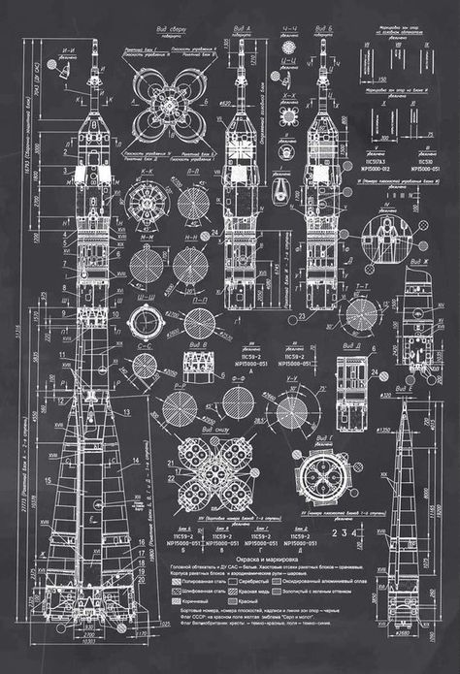

1️⃣ saturn rockets blueprint, in the style of industrialpunk, intricate embellishments, panel composition mastery, monumental scale, chalk art, grid-based, frostpunk --ar 59:86

2️⃣ drawing, drawings, and blueprints of an old spaceship, in the style of dark gray and white, goa-insprired motifs, clockpunk, piles/stacks, soviet, luxurious wall hangings, stencil-based --ar 59:86

3️⃣ a sheet of white paper with rocket tower blueprint, in the style of exquisite black and white engravings, ivanovich pimenov, chalk art, coded patterns, robert mccall, #screenshotsaturday, cybermysticsteampunk --ar 59:86

4️⃣ the plan for the cosmonaut's shack, in the style of intricate engravings, dark gray and white, vintage aesthetics, columns and totems, scientific accuracy, grid, large-scale canvases --ar 59:86

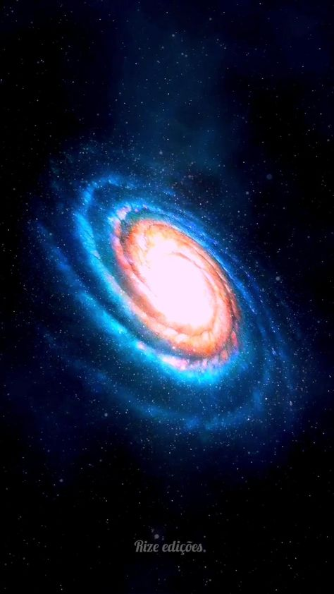

1️⃣ galaxy blue wallpaper, galaxy space wallpaper, galaxy wallpaper, spiral galaxy wallpaper, in the style of kadir nelson, animated gifs, light blue and orange, rendered in maya, tony orrico, артур скижали-вейс, spectacular show of ages --ar 59:105

2️⃣ the blue and green spiral galaxy with the white star in the center, in the style of animated gifs, kadir nelson, light red and gold, i can't believe how beautiful this is, rendered in maya, spectacular backdrops, massurrealism --ar 59:105

3️⃣ star galaxy wallpaper, in the style of rendered in maya, spiral group, golden ratio, swirling vortexes --ar 59:105

4️⃣ the milky way in front of a blue moon, in the style of animated gifs, spiral group, light red and light blue, rendered in maya, dazecore, metallic rotation, grandeur of scale --ar 59:105

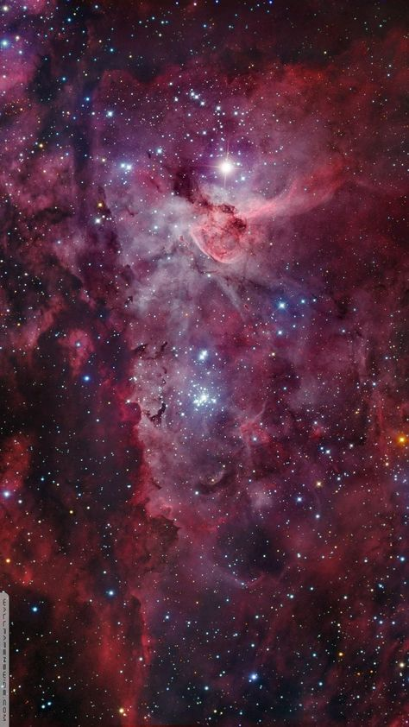

1️⃣ rda'shintar' star cluster in the outer space, in the style of dark crimson and pink, michael eastman, spectacular backdrops, rubens, ian miller --ar 59:105

2️⃣ nebula karanaki nebula karanaki canvas art print, in the style of dark crimson and pink, flickr, camera obscura, large scale, spectacular backdrops, baroque sci-fi, light indigo and red --ar 59:105

3️⃣ eta nova october / 13 | nasa, in the style of dark red and pink, spectacular backdrops, cosmic jester, large-scale canvases, dark aquamarine and red, frottage, elaborate --ar 59:105

4️⃣ galaxy nebula travel pillow, in the style of michael eastman, crimson, vibrant stage backdrops, peter lippmann, rubens, spectacular backdrops, dan colen --ar 59:105

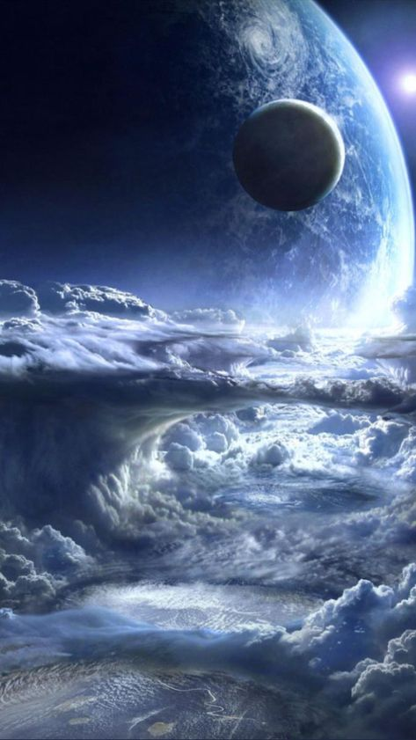

1️⃣ heavenly worlds wallpaper wallpapers hd wallpaper 2, in the style of realistic yet ethereal, precisionist art, dark blue and white, airbrush art, earl norem, sci-fi realism --ar 59:105

2️⃣ planet as seen from clouds in space, in the style of stephan martinière, dark silver and dark blue, cinematic sets, tintoretto, clyde caldwell, quiet contemplation, 3840x2160 --ar 59:105

3️⃣ the planet is in an area above the clouds, in the style of mystical realms, firecore, science fiction influences --ar 59:105

4️⃣ an earth and clouds looking at the sky, in the style of alien worlds, dark silver and blue, elaborate spacecrafts, airbrush art, cryengine, i can't believe how beautiful this is, hd --ar 59:105